**Exercise - Create an application to establish a connection with the MySQL database and perform basic database operations on it**

**Implementation:**

**Program:**

**db1.js : Create Database using Node.js**

// Import the MySQL module

var mysql = require('mysql');

// Establish a connection to the MySQL server

var con = mysql.createConnection({

    // Specify the host address of the MySQL server

    host: 'localhost',

    // Provide the username for accessing the MySQL server

    user: 'root',

    // Enter the password for the specified user

    password: '',

});

// Connect to the MySQL server using the established connection object

con.connect(function(err) {

    if (err) {

        // Handle any errors that occur during connection

        throw err;

    }

    console.log('Connected to MySQL database');

    // Define the SQL query to create a new database named 'employee1'

    var sql1 = 'CREATE DATABASE empDB1';

    // Execute the SQL query using the connection object

    con.query(sql1, function(err, result) {

        if (err) {

            // Handle any errors that occur during query execution

            throw err;

        }

        console.log('Database created successfully');

    });

});

**Output:**

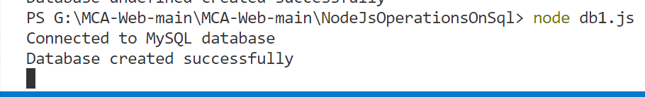

**db2.js : Create Table using Node.js**

// Import the MySQL module

var mysql = require('mysql');

// Establish a connection to the MySQL server, specifying the database 'empDB1'

var con = mysql.createConnection({

    // Specify the host address of the MySQL server

    host: 'localhost',

    // Provide the username for accessing the MySQL server

    user: 'root',

    // Enter the password for the specified user

    password: '',

    // Specify the database to connect to

    database: 'empDB1'

});

// Connect to the MySQL server using the established connection object

con.connect(function(err) {

    if (err) {

        // Handle any errors that occur during connection

        throw err;

    }

    console.log('Connected to MySQL database');

    // Define the SQL query to create a new table named 'empinfo'

    var sql1 = 'CREATE TABLE empinfo(id int(10), fname varchar(20), lname varchar(20), address varchar(50), salary int(20))';

    // Execute the SQL query using the connection object

    con.query(sql1, function(err, result) {

        if (err) {

            // Handle any errors that occur during query execution

            throw err;

        }

        console.log('Table created successfully');

    });

});

**Output:**

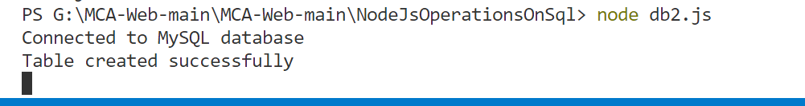

**multiRecord.js : Insert Multiple records into Table**

// Import the MySQL module

var mysql = require('mysql');

// Establish a connection to the MySQL server, specifying the database 'empDB1'

var con = mysql.createConnection({

    host: 'localhost',

    user: 'root',

    password: '',

    database: 'empDB1'

});

// Connect to the MySQL server using the established connection object

con.connect(function(err) {

    if (err) {

        // Handle any errors that occur during connection

        throw err;

    }

    console.log('Connected to MySQL database');

    // Prepare the SQL query to insert multiple records into the 'empinfo' table

    var sql = 'INSERT INTO empinfo (id, fname, lname, address, salary) VALUES ?';

    // Define the array of records to be inserted

    var records = [

        [1, 'John', 'Doe', '123 Main Street', 50000],

        [2, 'Jane', 'Smith', '456 Elm Street', 60000],

        [3, 'Peter', 'Jones', '789 Oak Street', 70000]

    ];

    // Execute the SQL query using the connection object and the array of records

    con.query(sql, [records], function(err, result) {

        if (err) {

            // Handle any errors that occur during query execution

            throw err;

        }

// To check how many records affected by the operation

        console.log('Number of records inserted:', result.affectedRows);

    });

});

**Output:**

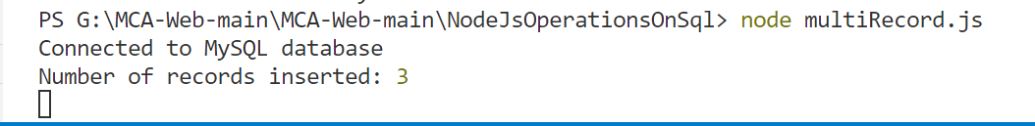

**Db.js : Select or Fetch the Records from the Table**

// Import the MySQL module

var mysql = require('mysql');

// Establish a connection to the MySQL server, specifying the database 'empDB1'

var con = mysql.createConnection({

    host: 'localhost',

    user: 'root',

    password: '',

    database: 'empDB1'

});

// Connect to the MySQL server using the established connection object

con.connect(function(err) {

    if (err) {

        // Handle any errors that occur during connection

        throw err;

    }

    console.log('Connected to MySQL database');

    // Define the SQL query to select all records from the 'empinfo' table

    var sql1 = 'SELECT * FROM empinfo';

    // Execute the SQL query using the connection object

    con.query(sql1, function(err, result) {

        if (err) {

            // Handle any errors that occur during query execution

            throw err;

        }

        console.log('Employee Data:');

        console.table(result);

    });

});

**Output:**

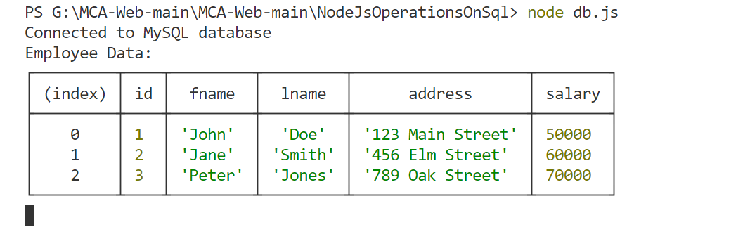

**Db5.js : Update record in the Table**

// Import the MySQL module

var mysql = require('mysql');

// Establish a connection to the MySQL server, specifying the database 'employee1'

var con = mysql.createConnection({

    host: 'localhost',

    user: 'root',

    password: '',

    database: 'empDB1'

});

// Connect to the MySQL server using the established connection object

con.connect(function(err) {

    if (err) {

        // Handle any errors that occur during connection

        throw err;

    }

    console.log('Connected to MySQL database');

    // Define the SQL query to update the address of an employee

    var sql1 = "UPDATE empinfo SET address = 'Talere' WHERE address = '123 Main Street'";

    // Execute the SQL query using the connection object

    con.query(sql1, function (err, result) {

        if (err) {

            // Handle any errors that occur during query execution

            throw err;

        }

        console.log(result.affectedRows + " record(s) updated");

    });

});

**Output:**

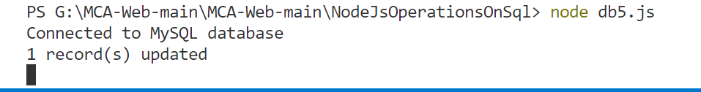

**Db6.js : Sort the record in the Table**

// Import the MySQL module

var mysql = require('mysql');

// Establish a connection to the MySQL server, specifying the database 'employee1'

var con = mysql.createConnection({

  host: 'localhost',

  user: 'root',

  password: '',

  database: 'empDB1'

});

// Connect to the MySQL server using the established connection object

con.connect(function (err) {

  if (err) throw err;

  // Define the SQL query to select all records from the 'empinfo' table and order them by 'fname'

  var sql1 = "SELECT * FROM empinfo ORDER BY fname";

  // Execute the SQL query using the connection object

  con.query(sql1, function (err, result) {

    if (err) throw err;

    console.log('Employee Data sorted by first name:');

    console.table(result);

  });

});

**Output:**

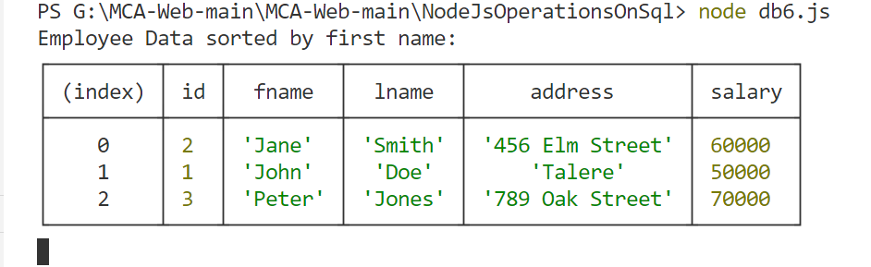

**Db4.js : Delete the Table or We can say drop the Table**

// Import the MySQL module

var mysql = require('mysql');

// Establish a connection to the MySQL server, specifying the database 'employee1'

var con = mysql.createConnection({

  host: 'localhost',

  user: 'root',

  password: '',

  database: 'empDB1'

});

// Connect to the MySQL server using the established connection object

con.connect(function (err) {

  if (err) throw err;

  console.log('Connected to MySQL database');

  // Define the SQL query to drop the 'empinfo' table

  var sql1 = 'DROP TABLE empinfo';

  // Execute the SQL query using the connection object

  con.query(sql1, function (err, result) {

    if (err) throw err;

    console.log('Table empinfo deleted successfully...');

  });

});

**Output:**

